The Parish Church of

St. Wilfrid, Mobberley

*Making Christ Known*

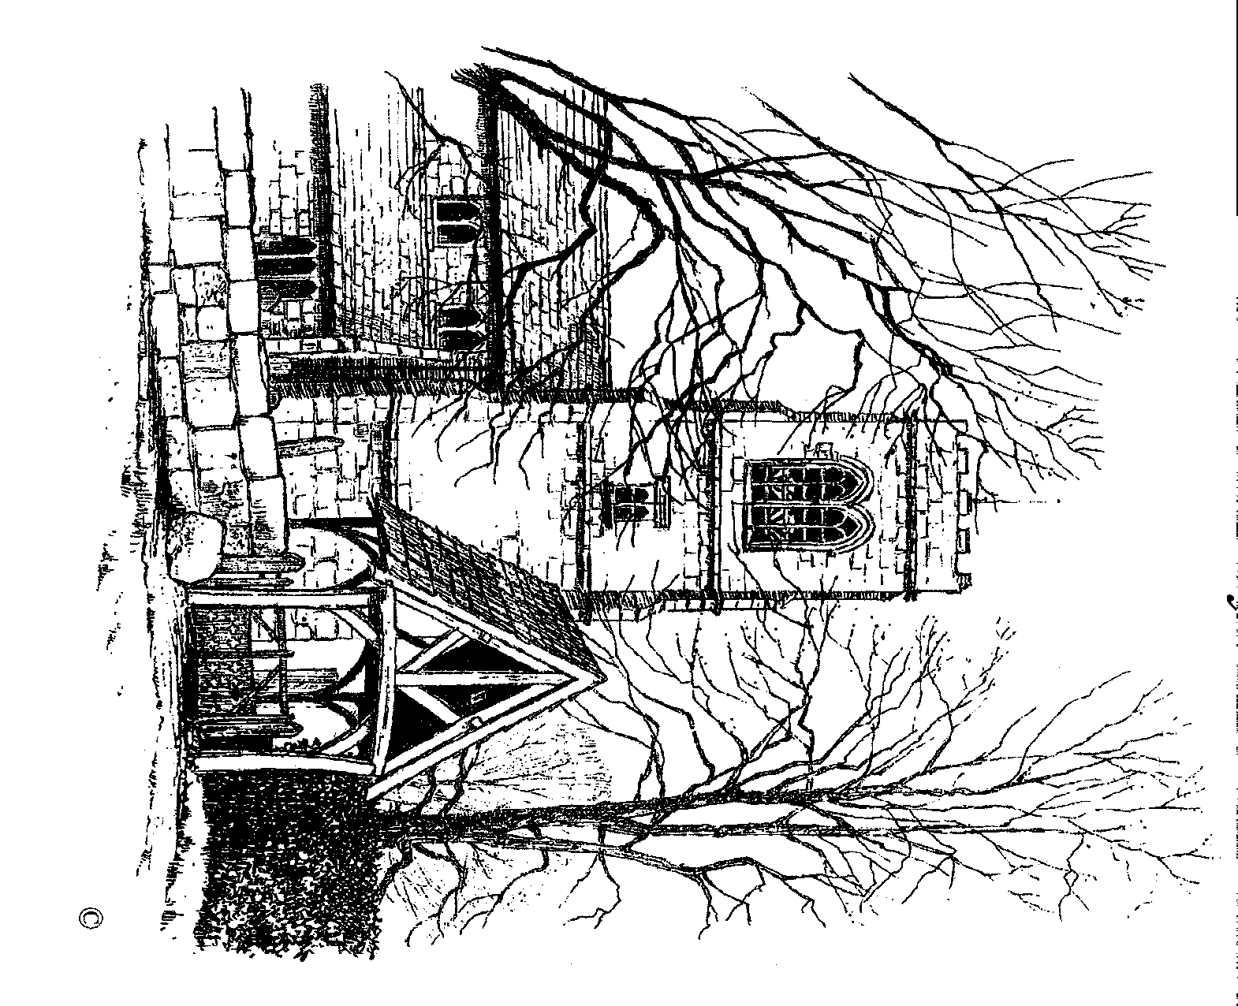

September 2023

**Church Diary for September 2023**

Fri. 1st Youth Club at the Beacon 7.00 p.m.

Sat. 2nd Men’s Breakfast  9.00 a.m.  
 The Beacon Drop-In 10.00 a.m.  
  
**Sun. 3rd The 13th Sunday after Trinity**  
 Said Holy Communion 8.30 a.m.  
 Sung Holy Communion 10.00 a.m.  
 Choral Evensong 6.30 p.m.

Mon. 4th Parents & Tots at The Beacon 10.00 a.m.

Tue. 5th The Beacon Drop-In 10.00 a.m.

Wed. 6th Communion at the Beacon 10.00 a.m.  
 Coffee Morning at the Beacon 10.30 a.m.  
 Alternative Service (Compline) 7.00 p.m.

Thu. 7th The Beacon Drop-In 10.00 a.m.  
 Doorway 7.30 p.m.  
 Greater Chapter 7.30 p.m.

Fri. 8th Youth Club at the Beacon 7.00 p.m.

Sat. 9th The Beacon Drop-In 10.00 a.m.  
 Wedding 2.00 p.m.  
  
**Sun. 10th The 14th Sunday after Trinity / Education Sunday** Said Holy Communion 8.30 a.m.  
 All-Age Family Service 10.00 a.m.  
 Choral Evensong 6.30 p.m.

Mon. 11th Parents & Tots at The Beacon 10.00 a.m.  
 Church Fabric Committee 11.00 a.m.  
 Faith & Worship Group 7.45 p.m.

Tue. 12th The Beacon Drop-In 10.00 a.m.  
 Victory Hall TDC 7.00 p.m.

Wed. 13th Communion at the Beacon 10.00 a.m.  
 Coffee Morning at the Beacon 10.30 a.m.

Thu. 14th The Beacon Drop-In 10.00 a.m.  
 Wedding Rehearsal 7.00 p.m.  
 Doorway 7.30 p.m.

 Fri. 15th Youth Club at the Beacon 7.00 p.m.

Sat. 16th The Beacon Drop-In 10.00 a.m.  
 Wedding 2.00 p.m.

**Sun. 17th The 15th Sunday after Trinity** Said Holy Communion 8.30 a.m.  
 Sung Holy Communion 10.30 a.m.  
 Choral Evensong 6.30 p.m.

Mon. 18th Faith & Worship Cttee 7.45 p.m.

Tue. 19th The Beacon Drop-In 10.00 a.m.

Wed. 20th Communion at the Beacon 10.00 a.m.  
 Coffee Morning at the Beacon 10.30 a.m.

Thu 21st The Beacon Drop-In 10.00 a.m.  
 Doorway 7.30 p.m.

Fri. 22nd Youth Club at the Beacon 7.00 p.m.

Sat. 23rd The Beacon Drop-In 10.00 a.m.  
 Wedding Rehearsal 2.00 p.m.  
  
**Sun. 24th The 16th Sunday after Trinity**  
 Said Holy Communion 8.30 a.m.  
 Family Service 10.00 a.m.  
 Choral Evensong 6.30 p.m.

Mon. 25th Parents & Tots at The Beacon 10.00 a.m.  
 PCC Meeting 7.00 p.m.

Tue. 26th The Beacon Drop-In 10.00 a.m.

Wed. 27th Communion at the Beacon 10.00 a.m.  
 Coffee Morning at the Beacon 10.30 a.m.

Thu. 28th The Beacon Drop-In 10.00 a.m.  
 Wedding 12.00 p.m.

Fri. 29th Church Decorating for Harvest 9.30 a.m.  
 Harvest Supper 7.30 p.m.

Sat. 30th Messy Church 10.00 a.m.  
 Church Open Day 10.00 a.m.

Dear Friends,

There is a well-known quote from the author CS Lewis that you will, no doubt, be aware of. It concerns the great question Jesus asked his disciples, “Who do you say that I am?” Lewis has the following to say, “A man who was merely a man and said the sort of things Jesus said would not be a great moral teacher. He would either be a lunatic… or else he would be the Devil of Hell. You must make your choice. Either this man was, and is, the Son of God, or else a madman or something worse. You can shut him up for a fool, you can spit at him and kill him as a demon or you can fall at his feet and call him Lord and God.”

The reason Lewis can say this of Jesus is, of course, the Cross. I sometimes believe that we have become so used to the symbol of the Cross that we don’t really see it anymore, don’t appreciate it’s power to shock, to confound and even to offend. We know what familiarity breeds.

We must never forget just how shocking the Cross was, and to many still is. This instrument of torture, humiliation and death upon which the Lord of Creation was crucified was, in St. Paul’s words, “a stumbling-block to Jews and foolishness to Gentiles.” Yet, in his letter to the Galatians, Paul was bold enough to assert, “May I never boast of anything except the cross of our Lord Jesus Christ, by which the world has been crucified to me, and I to the world.”

The Cross is the symbol of what Christ has done for us. It is a symbol of his suffering and pain, the price that he paid for us. Justice, and ultimately peace, can never be achieved by simply ignoring wrongdoing and evil, by pretending it never happened or doesn’t exist. Justice and righteousness can only be found through acknowledging and dealing with sin. So, acknowledging our sinfulness needs dealing with, the reason that we don’t fear condemnation is because the price has already been paid.

This is why the German theologian, Dietrich Bonhoeffer, wrote so beautifully about avoiding any idea of cheap grace. In his book, the Cost of Discipleship, he warned, “cheap grace is the preaching of forgiveness without requiring repentance, baptism without church discipline. Communion without confession. Cheap grace is grace without discipleship, grace without the cross, grace without Jesus Christ, living and incarnate”

Holy Cross Day is celebrated on the 14th September.

 Yours in Christ,

**Ian.**



**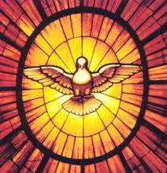Confirmation**

If any adults are interested in being Confirmed, or if you have been Confirmed but would like a ‘refresher’ there will be a meeting for interested parties on Wednesday 6th September at 6.00 p.m. at the Beacon. The group will meet each Wednesday at this time and the sessions will last around an hour.

If there are any children interested in being Confirmed this will normally meet separately but please come along to this initial meeting at which we shall arrange the day and times of meetings. Although children as young as 11 may be Confirmed it is my preference that they be teenagers, please speak to me about this is you have any questions.

**Initial Meeting**  
Wednesday 6th September at 6.00 p.m.  
The Beacon

**Holy Communion**

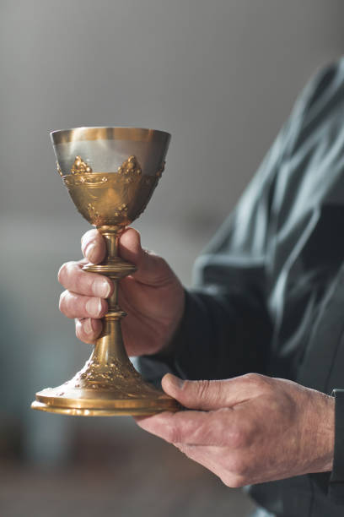 Please remember that from the start of September we shall revert to receiving the wine at Holy Communion from the common cup, or chalice. This is the last of our Covid restrictions imposed in 2020 to end.

If you do not yet feel confident in receiving from the chalice please remain at the rail after receiving the bread but keep your head and arms down until the communion assistant has past. This will help in the smooth running of the administration.

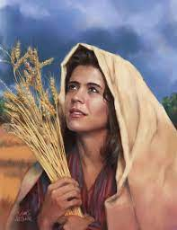**DOORWAY**

**"Women in the Bible"**

Having read the Bible and listened to our scripture readings every Sunday, how many women can you name from its sixty-six books?

That’s what we’ll be exploring in our Doorway autumn term. If you feel that women are the Bible’s unsung stars, hiding in the background, whose roles have perhaps been subjugated by male patriarchy, why not come and join us to learn more.

**DOORWAY@ THE BEACON – SEPTEMBER 7th 7.30pm.**

**Digital Giving**

Without doubt, the best way to donate to the church is by doing so regularly by setting up a standing order with your bank or through the envelope scheme as we get 100% of what you give. There may be occasions however when you want to make an irregular or even one-off donation and don’t have your computer or cash with you. In which case you can now give via your mobile phone by scanning the QR code below. This has now been Apple Pay and Google Pay enabled which makes it ever more straightforward.

The church has to pay a small fee on all donations received this way which is why we don’t want to encourage regular donations via this method. If you would like to set up a Standing Order please contact our Treasurer, Jean, whose details are on the back page.

To make a donation please scan the QR code below.

Thank you.

Google Pay and Apple Pay enabled



Thank you.

**Harvest at St. Wilfrid's**

There are lots of ways in which, by giving just a little time and effort, you can help make this our best Harvest celebration ever.

**Harvest Decorations**

There are three times in the year when the church is fully decorated and one of those times is harvest. Alongside the corn decorations we, of course, have the beautiful, autumnal coloured, flower arrangements. If you can assist in producing any kind of harvest display, floral or otherwise, then please put your name on the list in church, for more information or advice please speak to Liz Bridgford, her number is on the back of this magazine. The church will be decorated for harvest on Friday 29th September from 9.30 a.m.

**Harvest Supper**

Our annual Harvest Supper will take place at the Cricket Club on Friday 29th September at 7.30 p.m. This is a great and very friendly occasion and is followed by a quiz. Tickets cost £10 for adults and £5 for children, we will enjoy a traditional hot-pot supper and there will be a bar. Tickets on sale now.

**Harvest Refreshments**

The church will be open for visitors on Saturday 30th September between 10.00 and 4.00 and on Sunday 1st October between 1.00 and 4.00. During these times refreshments will be served. If you are able to help by baking and donating cakes or biscuits and in serving refreshments please contact Jean 873890.

**Harvest Flowers**

  
 It has been our custom to send a gift of Harvest flowers to people around the parish. If there is anybody you know who might appreciate a bunch of flowers please put their name and address down on the list in church, or contact the Rector. Please remember also to bring a bunch of flowers with you to any of our Harvest services.

**Harvest Services**

Our 10 a.m. service is a traditional Harvest Communion service where we “raise the song of Harvest Home” and give thanks to God for the skills and labour of those who produce the food we eat and of course give thanks and praise to Him for the bounty we enjoy. Our 6.30 p.m. service has established itself over the years as a firm favourite, a mix of readings both sacred and secular alongside a selection of rousing Harvest and Creation hymns. Come along to any of our Harvest services and why not invite a neighbour or friend, they won’t be disappointed.

**HARVEST FESTIVAL EVENTS**

**Saturday 30th September & Sunday 1st October 2023**

The Church will be open

Saturday 10.00a.m. to 4.00p.m.

Sunday 1.00p.m. to 4.00p.m.

**Special events on Saturday**

Gift Day 10.00a.m. to 4.00p.m.

Musical Entertainment by

Mobberley School Choir @ 2.15p.m.

**Special events on Sunday**

Organ Recital by David Carlston Williams @ 2.30p.m.

**Harvest Festival Services**

8.30a.m. Said Holy Communion

10.00a.m. Harvest Thanksgiving

6.30p.m. Harvest Songs of Praise

**All are welcome**

Refreshments are available throughout the weekend

To make a donation please scan the QR code below.

Thank you.

Google Pay and Apple Pay enabled



**Gift Day**

As we once again join together to give thanks to God for the gifts of the harvest I invite you to look back over the past year and to give thanks for the personal gifts which you have received.

The church community at St. Wilfrid’s strives to provide support and help where it is needed and our outreach mission at The Beacon provides a number of activities for both the youth as well as the older members of our society.

But to enable us to continue to do this the church needs not only your physical presence but also your financial support. Thank you to all who continue to give regularly; and to those of you who are able, and currently don’t give on a regular basis, please will you consider giving by standing order or by the weekly envelope scheme this way we can ensure that the church here in Mobberley continues to provide not only for weekly worship but also for funeral, wedding and baptism services in the years to come.

A standing order form is enclosed with this magazine. And on Gift Day – 30th September, when the church will be open between 10.00 and 4.00 for the viewing of the harvest decorations and when in the afternoon entertainment will be provided by the Mobberley School Choir, we also invite you to take the opportunity to make a thanksgiving donation towards the upkeep of the church. Thank you for your help and support.

Jean Underhill for the Finance Committee

**From St. Wilfrid’s Registers –**



***Baptisms in July***

23rd Olivia Grace Montgomery Moston Street, Dukenfield



***Weddings in July***

9th Harvey Jackson & Tamara Bennett Rowley Way, Knutsford

27th Dylan Berry & Grace Garner Allerton Road, Wallasey

***Weddings in August***

31st Nicholas Banks & Lowri Williams West Way, Holmes Chapel

so02914_

***Funerals in August***

25th Nicholas Dolan Cheadle St, Higher Openshaw Church

***Year’s Mind in September***

Norris Garside

Benjamin Barnhill

John Nichols

David Hunter

John Pennington

Hannah Wooley

Leslie Davenport

Doris Wills

Thelma Wilding

Joyce Pemberton

Violet Broadhurst

Joyce Roscoe

Charles Mills

Doris Dobell

Cecil Stuart John

Meg Taylor

Stanley Bowler

Gideon Drake

Cyril Dale

Renie Goostrey

Joseph Rogan

Edna Corry

Geoffrey

Wilkinson

Beatrice Bradley

Ronald Dennis

Linda Smith

Kenneth Morris

Marie-Louise Gunn

William Davies

Nora Pike

Frederick Blackmore

Frederick Warburton

Douglas Lancaster

Hisajee Edoo

Freda Waldron

Diana Seed

Albert Long

Nancy Norbury

Paul Greaves

Annie Leather

Hilda Livingstone

Frederick Hambleton

Val Gurney

Marjorie Bradley

Florrie Pike

Clifford Bradley

Jack Tulley

Jessica Campbell-Lockey

Roy Shillinglaw

Emily Bell

Edward Weetman

Jack Fryer

Maud Mead

James Caveney

Robert Wilding

Ann Fairhead

Kate Hatton

Mary Pike

Don Riley

*Those whose anniversary of death is within the last 10 years are remembered on the weekly newssheet and recalled in our Sunday services.**Those listed above are those whose anniversary is more than 10-years ago.*