The Parish Church of

St. Wilfrid, Mobberley





April 2024

**Church Diary for April 2024**

Mon. 1st Parents & Tots 10.0 a.m.

Tue. 2nd Parish Lunch 12.30 p.m.

Thu. 4th Doorway 7.45 p.m.

Fri. 5th Youth Club 6.00 p.m.

Sat. 6th Men’s Breakfast 9.00 a.m.  
  
**Sun. 7th The 2nd Sunday of Easter** Said Holy Communion 8.30 a.m.  
 Sung Holy Communion 10.00 a.m.  
 Choral Evensong 6.30 p.m.

Mon. 8th Parents & Tots 10.00 a.m.

Wed. 10th Communion at the Beacon 10.00 a.m.  
 Coffee Morning at the Beacon 10.30 a.m.  
 Wednesday Matinee 2.00 p.m.

Thu. 11th Doorway 7.45 p.m.

Fri. 12th Youth Club 6.00 p.m.

Sat. 13th Messy Church 10.00 a.m.

**Sun. 14th The 3rd Sunday of Easter** Said Holy Communion 8.30 a.m.  
 Family Service 10.00 a.m.  
 Choral Evensong 6.30 p.m.

Mon. 15th Parents & Tots 10.00 a.m.

Tue. 16thSchool Easter Service 9.30 a.m.  
Victory Hall TDC 7.00 p.m.

Wed. 17th Communion at the Beacon 10.00 a.m.  
 Coffee Morning at the Beacon 10.30 a.m.

Thu 18th Doorway 7.45 p.m.

Fri. 19th Youth Club 6.00 p.m.

**Sun. 21st The 4th Sunday of Easter**  
 Said Holy Communion 8.30 a.m.

Sung Holy Communion 10.00 a.m.  
 Annual Parochial Church Meeting 11.30 a.m.  
 Choral Evensong 6.30 p.m.

Mon. 22nd Parents & Tots 10.00 a.m.  
 PCC Standing Committee 7.30 p.m.

Wed. 24h Communion at the Beacon 10.00 a.m.  
 Coffee Morning at the Beacon 10.30 a.m.  
 Movie Matinee 2.00 p.m.

Thu. 25th Doorway 7.45 p.m.

Fri. 26th Youth Club 6.00 p.m.

Sat. 27th Church Spring Clean 10.00 a.m.  
  
**Sun. 28th The 5th Sunday of Easter**  
 Said Holy Communion 8.30 a.m.  
 Family Service 10.00 a.m.  
 Sung Holy Communion 6.30 p.m.

Mon. 29th Parents & Tots 10.00 a.m.

Wed. 31st Communion at the Beacon 10.00 a.m.  
 Coffee Morning at the Beacon 10.30 a.m.

**Sabbatical 2025**

Clergy in the Church of England, and most other denominations, are encouraged to take a sabbatical. This is an extended period of time (90 days) which is neither work nor holiday but an opportunity to be refreshed as a minister, to live differently, to study and explore, to look again at ministry, work and lifestyle, to let God speak to them afresh.

Although clergy may take sabbaticals every 7 or 8 years I have only taken one in 33 years, and that was 12 years ago. I have applied to the Bishop who has given his permission and I have consulted with the PCC. I intend to take June - August 2025 for my sabbatical. I am letting you all know well in advance because a lot of planning is required and I didn’t want people to be confused or concerned by that planning process.

**Ian**

Dear Friends,

Alleluia! Christ is risen! We say it but do we feel it?

There is a fine line between correction and over correction. The western Church in the 15th and 16th centuries was definitely in need of correction. The Church was riddled with internecine rivalries, corruption was endemic, particularly the sale of ‘Indulgencies’. There was also a great gulf between the educated clergy and the illiterate laity which made the ordinary people entirely dependent upon the clergy for the understanding of scripture and so, ultimately, what was necessary for their salvation.

The response to this was what we call the Reformation, the first act of which was to put the Bible into the hands of ordinary men and women (the educated ones at least), written in their own language. This new spirit blew through the western Church leading the stripping out of those things not directly connected to the Word of God. Medieval murals were pained over and replaced with passages of scripture, statues were removed because they distracted people away from the worship of the one God. Even the measuring of time was changed, from the flows of ‘tides’ to numbers. How different it would have been had Shakespeare written, “And gentlemen in England now a-bed, Shall think themselves accursed they were not here, And hold their manhood’s cheap, whiles any speaks That fought with us upon the 25th October.”

So much of this was needed but, as I suggested at the start, there was an over correction. The Reformation was cerebral, learned, academic. Images were replaced with words, aesthetic beauty replaced with ascetic plainness, poetry with earnestness, the heart with the mind. Yet faith is not a purely intellectual exercise, as John Wesley discovered when he found his heart ’strangely warmed’; faith speaks to our hearts as well as our heads, courage goes beyond calculated risk, hope lies in what is unseen. When we read or hear the gospels we need to ever remember these are not stories even less are they parables. These are events, events that we are encouraged to step into, to feel, experience and share; events to ‘know’ in our very heart of hearts.

This Easter may we all experience and joy of Christ’s resurrection and the new life which he promises to all who believe and trust in him.

Yours in Christ,  
  **Ian.**



**Church Spring Clean**



Ever y year we hold a Church Spring Clean to freshen up the building and undertake any routine maintenance tasks that might need doing. We are not very prescriptive about what people do, inside the church there is dusting, sweeping, polishing, cobweb removal etc, outside there is weeding, drain clearance, grounds maintenance, path de-mossing, gate oiling etc.

If you have ever sat there on a Sunday and thought, “That cobweb just keeps getting longer/dustier/closer” then here is your chance to attack it; or if you have thought, “That corner of the graveyard could do with tidying up”, then here’s your excuse to give it a go and, as a ‘thank you’ and an added incentive, there will be some lunch provided at 12.30ish to wash away the dust and dirt.

So dust off your marigolds, dusters, secateurs and rakes and come and join us.

**Church Spring Clean**

Saturday 27th April

10.00 a.m.

**Ian.**

**Annual Parochial Church Meeting**

**Our Annual Parochial Church Meeting (APCM) will take place on Sunday 21st April at 11.30 a.m.**

The APCM is the most important meeting in the life of our church. At it we receive the Annual Report, scrutinise the accounts and appoint our Churchwardens, Sidesmen and women and PCC members.

All notices will be posted shortly and I encourage you to consider standing for these positions, we are particularly short of Sidesmen and Sideswomen who are the ‘face’ of the church when people come on a Sunday There are also a large number of PCC vacancies to fill so please consider standing for this and taking an active role in the governance of our church.

The APCM is in fact two separate meetings combined. The first is the Annual Vestry Meeting which serves solely for the purpose of electing the Churchwardens. This is open to everybody and those on the Electoral Roll and everybody who is resident in the parish is permitted to vote.

The second meeting is the AGM which transacts all the other business. Whilst any may attend only those on the Electoral Roll are permitted to vote.

Attendance at the APCM is a right and a responsibility of all church members so please do make it a priority to attend.

**Ian.**

**Upcoming Events**

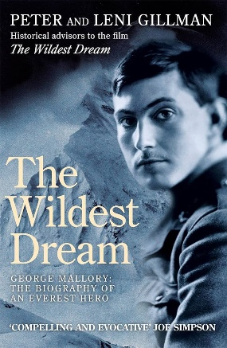

**Mallory Remembered**

In 1924, Mobberley’s most famous son George Mallory and his companion Andrew Irvine disappeared during a valiant bid to reach the world’s highest summit. Peter and Leni Gillman, authors of the book ‘The Wildest Dream’, will be giving as talk about George Mallory here at St. Wilfrid’s as part of our centenary celebrations of Mallory.

**Mallory Remembered**

A Talk by Peter & Leni Gillman

Thursday 23rd May at 7.30 p.m.



**Mallory & the Mountain**

Continuing our celebration of Mallory’s centenary there will be a production of Mallory and the Mountain, a musical based on Mallory’s attempt to climb Everest, performed in church. First performed at The Lowry Theatre this musical by Ollie Mills speaks of the human cost of Mallory’s obsession.

**Mallory on the Mountain**

Saturday 8th June at 7.30 p.m.



**Cream Tea at the Rectory**

We shall again be holding our Cream Tea on the Rectory Lawn, there will be games for the children with a lovely cream tea with either a hot drink or, for a couple of quid extra, a glass of fizz. We keep our fingers crossed for a sunny day.

**Cream Tea at the Rectory**

Saturday 6th July

3.00 - 5.00 p.m.

**April @ The Beacon**

***“MEN’S BREAKFAST*” meet on the first Saturday of every month** **at 9.00am (April 6th).**

There’s a misconception that men are reluctant to speak about themselves and/or “sensitive” issues. That doesn’t happen here, try shutting us up! Perhaps it’s the brew and the sausage/bacon baps!

*

***“PARENTS AND TOTS”* every Monday, 10.00am - 12.00pm. (NOT Bank Holiday 1st April).**

Toddlers bring along their parents to play, chat and have a brew in a safe and warm environment. Mums with bumps also welcome.

*

**“*COMMUNION SERVICE”* every Wednesday at 10.00am followed by *Tea or Coffee* at 10.30am.**

**\***

**“*KNIT & NATTER”* meets Wednesdays 3rd & 17th at 2.00pm.**

If you’re of a Knitting and Nattering disposition you’ll be made most welcome.

*

***“MOVIE MATINÉE”* meets Wednesdays 10th & 24th at 1.30pm for 2.00pm.**

**On April 10th** come and enjoy the classic musical **“The King and I” starring Deborah Kerr and Yul Brynner. On April 24** we have a complete contrast with **“The Bourne Identity”** **starring Matt Damon,** the first film in the Bourne franchise.

*

***“DOORWAY”,* our study group, meets every Thursday at 7.45pm.**

We’re continuing our journey through St. John’s Gospel with the inspiring Bruce Gore.

*

**“*YOUTH CLUB”* meets every Friday from 6.00pm - 8.00pm. (NOT 5th & 12th, school holidays).**

Lots of activities, board games, TV, Video games, Xbox etc. and don’t forget the Tuck shop. Great fun for all youngsters age nine and upwards.

*

If you need more information on any of the above activities speak to either John Grainger - 872549 or John and Jo-Ann Hennerley – 872784. April 2024.

**Mallory Remembered**

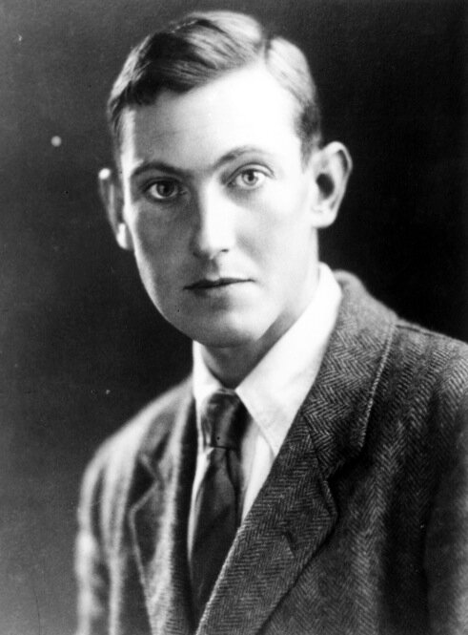

This year marks the centenary of the death of Mobberley’s most famous son, George Leigh Mallory. George, along with his walking companion Andrew ’Sandy’ Irvine, was famously ’lost to human sight’ on the 8th June 1924 making an attempt to reach the peak of Mount Everest. St. Wilfrid’s has a close connection with the Mallory family as they were, for centuries, the patrons of the parish and a number of the family, including George’s father, Herbert, and grandfather, George, were Rectors here and both of them are buried in the graveyard here.

George’s body was found by an expedition specifically put together for the task in 1999. His body was frozen into the surrounding rock and could not be removed without causing enormous damage so instead a cairn was erected over him and a prayer of committal offered.

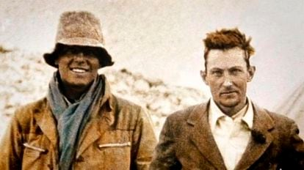

In this Centenary year there will be a number of events taking place in th e early summer. These include events taking place in church. At the moment we have arranged a talk about Mallory by Peter Gillman, the author of the Mallory biography, ‘The Wildest Dream’. This will be a ticketed event on **Thursday 23rd May**. On the **Saturday 8th June**, the actually centenary of his death, it is hoped that a commemorative statue to Mallory will be unveiled but also there will be a production of **’Mallory on the Mountain’**, a musical by Ollie Mills that was previewed at The Lowry.

I am sure that more events will be announced over the coming months but please put these dates in your diaries, invite some friends to join you, and let us celebrate the life of this extraordinary man.

**Ian**.

Why would you want to climb Mount Everest?” George Mallory was asked this question in 1924 and gave the most obvious answer: “Because it’s there“.

“One comes to bless the absolute bareness, feeling that here is a pure beauty of form, a kind of ultimate harmony.”

– George Mallory, Letter to his wife Ruth Mallory (1921)

**The Magic of the Movies**

On the **10th and 24th of April** we will be screening two classics at The Beacon.

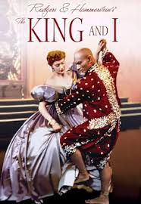**Wednesday 10th February**

'The King & I'

Come and enjoy the classic musical **“The King and I”** starring Deborah Kerr and Yul Brynner. Based on the book ‘Anna and the King of Siam’ by Anna Leonowens which detailed her time as governess to King Mongkut of Siam who was trying to modernize his country. The story speaks of the conflicts but also the love which neither can admit.

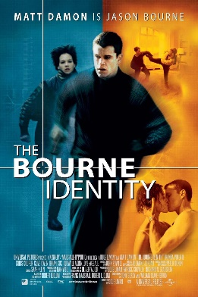 **Wednesday 24th February**

‘The Bourne Identity’

Based on the book of the same name by American author Robert Ludlum. Italian fisherman rescue a man from the sea, he has bullet wounds but no memory of who he is although the man proves to be fluent in numerous languages and exhibits advanced combat skill. The only clue to his identity is a code for a safe deposit box in Zurich.

The films are completely free to watch, although of course donations are always welcome, and the doors open at 1.30 p.m. and the films start at 2.00 p.m.

**Beacon Drop -In**

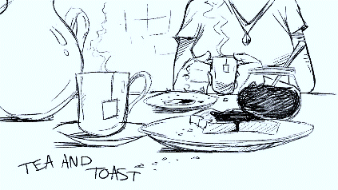

From when The Beacon opened Jo and John Hennerley and John Grainger have open it three times a week as a drop-in. The numbers coming in have fluctuated but have always been very few, certainly compared to the number of hours it has been open. It has been agreed that we should discontinue this model for the time being and look to different activities although The Beacon shall still be open on Saturdays for a brew and a chat..

I would like to take this opportunity to the Johns and Jo-Ann for their dedication in operating this service for so long.

**From St. Wilfrid’s Registers –**

***Baptisms in March***

28th Hugo Wolfee Beech Altrincham Road, Wilmslow

***Year’s Mind in April***

Edward Leech

Catherine Mais

Ann Brindley

Kenneth Holt

Toby Fryer

Anne Caveney

Brian Axten

Dorothy Hulme

George Way

Dorothy Hadfield

Yvonne Frayling

Kenneth Oldham

Derek Parmenter

Beatrice Mason

George Waite

Kathleen Pennington

Khanikhah Guy

Frances Smith

Kenneth Walker

Peter Speakman

Anthony Dolan

Marjorie Bayley

William Daniel

Agnes Green

Harry Turner

Averilda Street

Bessie Morris

Laura Hender

Sandy Storey

Betty Unwin

Eric Chicot

Frank Butler

Alan Gentles

Edith Harpham

Albert Virgo

Charlotte Morley

Wayne Southern

Nancy Acton

Rosalind Haller

Anthony Broad

Dr. Harry Savage

Joseph Fox

Eliza Clarke

Ian Sellars

James Bowler

William Mason

Margaret McKeand

Leo Coops

Marjorie Bell

Robert Ward

Geoffrey Deakin

Frances Walker

Alan Martin

Louisa Finch

Ralph Croxall

*Where can I go from your spirit? Or where can I flee from your presence? If I ascend to heaven, you are there; if I make my bed in Sheol, you are there. If I take the wings of the morning and settle at the farthest limits of the sea, even there your hand shall lead me, and your right hand shall hold me fast.*

**Psalm 139:7-10**

**Please pray for the above, that God might shelter them in their joy and comfort them in their sorrow.**